**AWS Scala Practice**

**Job Name: Scala_Practice_1**

**Script:**

import com.amazonaws.services.glue.GlueContext

import com.amazonaws.services.glue.MappingSpec

import com.amazonaws.services.glue.errors.CallSite

import com.amazonaws.services.glue.util.GlueArgParser

import com.amazonaws.services.glue.util.Job

import com.amazonaws.services.glue.util.JsonOptions

import org.apache.spark.SparkContext

import scala.collection.JavaConverters._

import com.amazonaws.services.glue.DynamicFrame

import org.apache.spark.sql.SQLContext

import com.amazonaws.services.glue.errors.CallSite

object SparkSqlQuery {

def execute(glueContext: GlueContext, sqlContext: SQLContext, query: String, mapping: Map[String, DynamicFrame]) : DynamicFrame = {

for ((alias, frame) <- mapping) {

frame.toDF().createOrReplaceTempView(alias)

}

val resultDataFrame = sqlContext.sql(query)

return DynamicFrame(resultDataFrame, glueContext)

}

}

object GlueApp {

def main(sysArgs: Array[String]) {

val spark: SparkContext = new SparkContext()

val glueContext: GlueContext = new GlueContext(spark)

val sql: SQLContext = new SQLContext(spark)

// @params: [JOB_NAME]

val args = GlueArgParser.getResolvedOptions(sysArgs, Seq("JOB_NAME").toArray)

Job.init(args("JOB_NAME"), glueContext, args.asJava)

// Script generated for node AWS Glue Data Catalog

val AWSGlueDataCatalog_node1646633936301 = glueContext.getCatalogSource(database="amulya_db", tableName="covid_filtered_data_csv", transformationContext="AWSGlueDataCatalog_node1646633936301").getDynamicFrame()

// Script generated for node SQL

val SqlQuery0: String = """select location,sum(total_cases) from Covid_Case group by location

|""".stripMargin

val SQL_node1646633973725 = SparkSqlQuery.execute(glueContext = glueContext, sqlContext = sql, query = SqlQuery0, mapping = Map("Covid_Case" -> AWSGlueDataCatalog_node1646633936301)

)

// Script generated for node Amazon S3

val repartition=SQL_node1646633973725.repartition(1)

val AmazonS3_node1646634397536 = glueContext.getSinkWithFormat(connectionType="s3", options=JsonOptions("""{"path": "s3://training-labtarget1/TrainingLab/Amulya/OUTPUT/Scala/Scala_Practice_1/", "partitionKeys": []}"""), transformationContext="AmazonS3_node1646634397536", format="csv").writeDynamicFrame(repartition)

Job.commit()

}

}

**Output:**

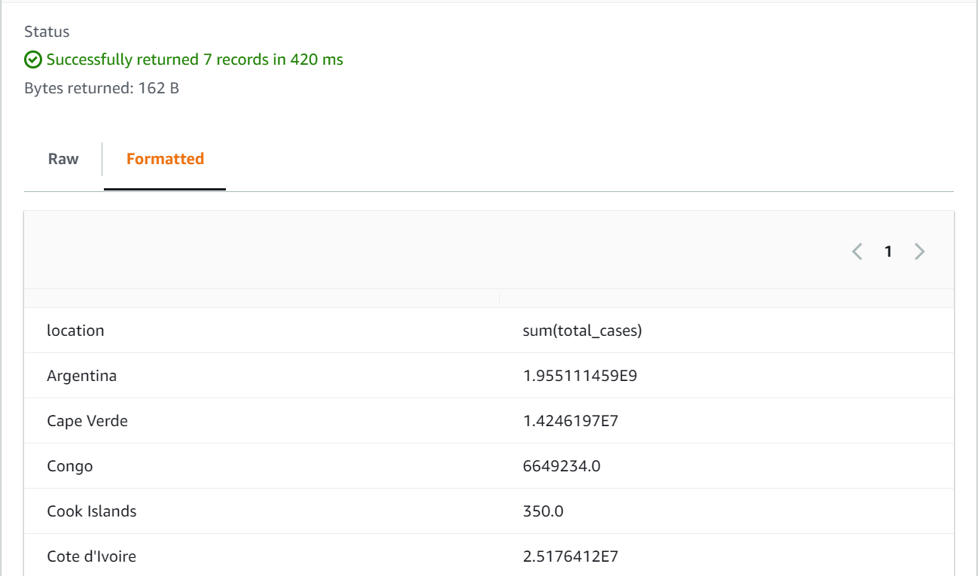

**Job Name: Scala_Practice_2**

**Script:**

import com.amazonaws.services.glue.GlueContext

import com.amazonaws.services.glue.MappingSpec

import com.amazonaws.services.glue.errors.CallSite

import com.amazonaws.services.glue.util.GlueArgParser

import com.amazonaws.services.glue.util.Job

import com.amazonaws.services.glue.util.JsonOptions

import org.apache.spark.SparkContext

import scala.collection.JavaConverters._

import com.amazonaws.services.glue.DynamicFrame

import org.apache.spark.sql.SQLContext

import com.amazonaws.services.glue.errors.CallSite

object SparkSqlQuery {

def execute(glueContext: GlueContext, sqlContext: SQLContext, query: String, mapping: Map[String, DynamicFrame]) : DynamicFrame = {

for ((alias, frame) <- mapping) {

frame.toDF().createOrReplaceTempView(alias)

}

val resultDataFrame = sqlContext.sql(query)

return DynamicFrame(resultDataFrame, glueContext)

}

}

object GlueApp {

def main(sysArgs: Array[String]) {

val spark: SparkContext = new SparkContext()

val glueContext: GlueContext = new GlueContext(spark)

val sql: SQLContext = new SQLContext(spark)

// @params: [JOB_NAME]

val args = GlueArgParser.getResolvedOptions(sysArgs, Seq("JOB_NAME").toArray)

Job.init(args("JOB_NAME"), glueContext, args.asJava)

// Script generated for node S3 bucket

val S3bucket_node1 = glueContext.getSourceWithFormat(formatOptions=JsonOptions("""{"quoteChar": "\"", "withHeader": true, "separator": ","}"""), connectionType="s3", format="csv", options=JsonOptions("""{"paths": ["s3://training-labtarget1/TrainingLab/Amulya/OUTPUT/AWS_UseCase/Covid_Filtered_Data.csv"], "recurse": true}"""), transformationContext="S3bucket_node1").getDynamicFrame()

// Script generated for node SQL

val SqlQuery0: String = """select location, sum(total_cases) as active_cases ,sum(icu_patients) as critical_cases from Covid_Case group by location

|

|""".stripMargin

val SQL_node1646636888083 = SparkSqlQuery.execute(glueContext = glueContext, sqlContext = sql, query = SqlQuery0, mapping = Map("Covid_Case" -> S3bucket_node1)

)

// Script generated for node Amazon S3

val repartition=SQL_node1646636888083.repartition(1)

val AmazonS3_node1646636966045 = glueContext.getSinkWithFormat(connectionType="s3", options=JsonOptions("""{"path": "s3://training-labtarget1/TrainingLab/Amulya/OUTPUT/Scala/Scala_Practice_2/", "partitionKeys": []}"""), transformationContext="AmazonS3_node1646636966045", format="csv").writeDynamicFrame(repartition)

Job.commit()

}

}

**Output:**

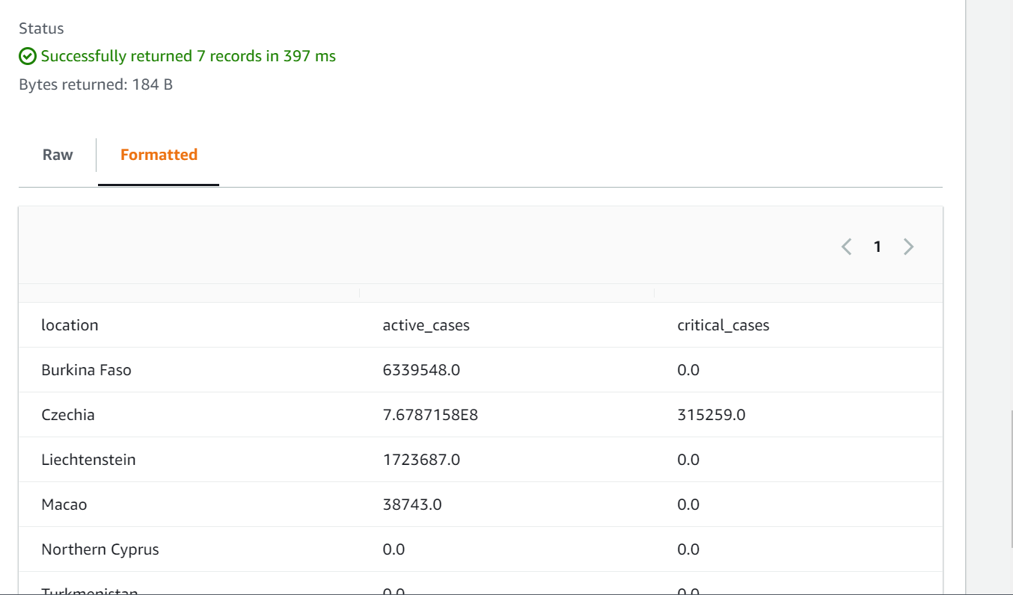

**Job Name: Scala_Practice_3**

**Script:**

import com.amazonaws.services.glue.GlueContext

import com.amazonaws.services.glue.MappingSpec

import com.amazonaws.services.glue.errors.CallSite

import com.amazonaws.services.glue.util.GlueArgParser

import com.amazonaws.services.glue.util.Job

import com.amazonaws.services.glue.util.JsonOptions

import org.apache.spark.SparkContext

import scala.collection.JavaConverters._

object GlueApp {

def main(sysArgs: Array[String]) {

val spark: SparkContext = new SparkContext()

val glueContext: GlueContext = new GlueContext(spark)

// @params: [JOB_NAME]

val args = GlueArgParser.getResolvedOptions(sysArgs, Seq("JOB_NAME").toArray)

Job.init(args("JOB_NAME"), glueContext, args.asJava)

// Script generated for node Amazon Redshift

val AmazonRedshift_node1646638206955 = glueContext.getCatalogSource(database="dev", redshiftTmpDir=args("TempDir"), tableName="covid_case", transformationContext="AmazonRedshift_node1646638206955").getDynamicFrame()

// Script generated for node Select Fields

val SelectFields_node1646638247337 = AmazonRedshift_node1646638206955.selectFields(paths=Seq("total_cases", "total_deaths", "recoveries"), transformationContext="SelectFields_node1646638247337")

// Script generated for node Amazon S3

val repartition=SelectFields_node1646638247337.repartition(1)

val AmazonS3_node1646638270814 = glueContext.getSinkWithFormat(connectionType="s3", options=JsonOptions("""{"path": "s3://training-labtarget1/TrainingLab/Amulya/OUTPUT/Scala/Scala_Practice_3/", "partitionKeys": []}"""), transformationContext="AmazonS3_node1646638270814", format="csv").writeDynamicFrame(repartition)

Job.commit()

}

}

**Output:**

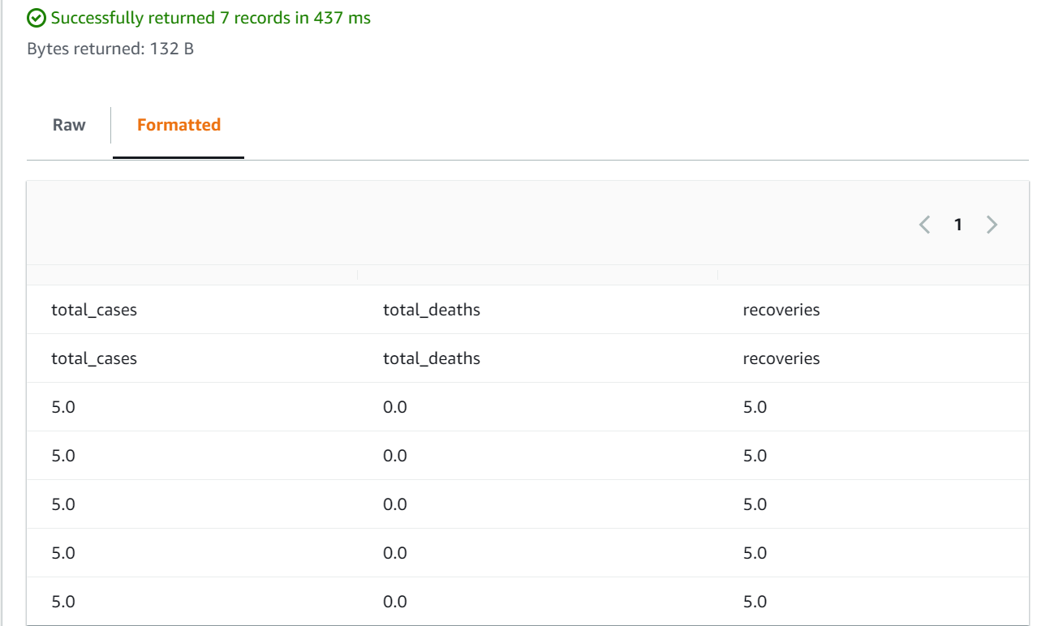

**Job Name: Scala_Practice_4**

**Script:**

import com.amazonaws.services.glue.GlueContext

import com.amazonaws.services.glue.MappingSpec

import com.amazonaws.services.glue.errors.CallSite

import com.amazonaws.services.glue.util.GlueArgParser

import com.amazonaws.services.glue.util.Job

import com.amazonaws.services.glue.util.JsonOptions

import org.apache.spark.SparkContext

import scala.collection.JavaConverters._

import com.amazonaws.services.glue.DynamicFrame

import org.apache.spark.sql.SQLContext

import com.amazonaws.services.glue.errors.CallSite

object SparkSqlQuery {

def execute(glueContext: GlueContext, sqlContext: SQLContext, query: String, mapping: Map[String, DynamicFrame]) : DynamicFrame = {

for ((alias, frame) <- mapping) {

frame.toDF().createOrReplaceTempView(alias)

}

val resultDataFrame = sqlContext.sql(query)

return DynamicFrame(resultDataFrame, glueContext)

}

}

object GlueApp {

def main(sysArgs: Array[String]) {

val spark: SparkContext = new SparkContext()

val glueContext: GlueContext = new GlueContext(spark)

val sql: SQLContext = new SQLContext(spark)

// @params: [JOB_NAME]

val args = GlueArgParser.getResolvedOptions(sysArgs, Seq("JOB_NAME").toArray)

Job.init(args("JOB_NAME"), glueContext, args.asJava)

// Script generated for node Amazon S3

val AmazonS3_node1646642980603 = glueContext.getSourceWithFormat(formatOptions=JsonOptions("""{"quoteChar": "\"", "withHeader": true, "separator": ","}"""), connectionType="s3", format="csv", options=JsonOptions("""{"paths": ["s3://training-labtarget1/TrainingLab/Amulya/OUTPUT/AWS_UseCase/Covid_Filtered_Data.csv"], "recurse": true}"""), transformationContext="AmazonS3_node1646642980603").getDynamicFrame()

// Script generated for node SQL

val SqlQuery0: String = """select date, new_cases from Covid_Case order by new_cases desc

|""".stripMargin

val SQL_node1646643036791 = SparkSqlQuery.execute(glueContext = glueContext, sqlContext = sql, query = SqlQuery0, mapping = Map("Covid_Case" -> AmazonS3_node1646642980603)

)

// Script generated for node Amazon S3

val repartition=SQL_node1646643036791.repartition(1)

val AmazonS3_node1646643101992 = glueContext.getSinkWithFormat(connectionType="s3", options=JsonOptions("""{"path": "s3://training-labtarget1/TrainingLab/Amulya/OUTPUT/Scala/Scala_Practice_4", "partitionKeys": []}"""), transformationContext="AmazonS3_node1646643101992", format="csv").writeDynamicFrame(repartition)

Job.commit()

}

}

**Output:**

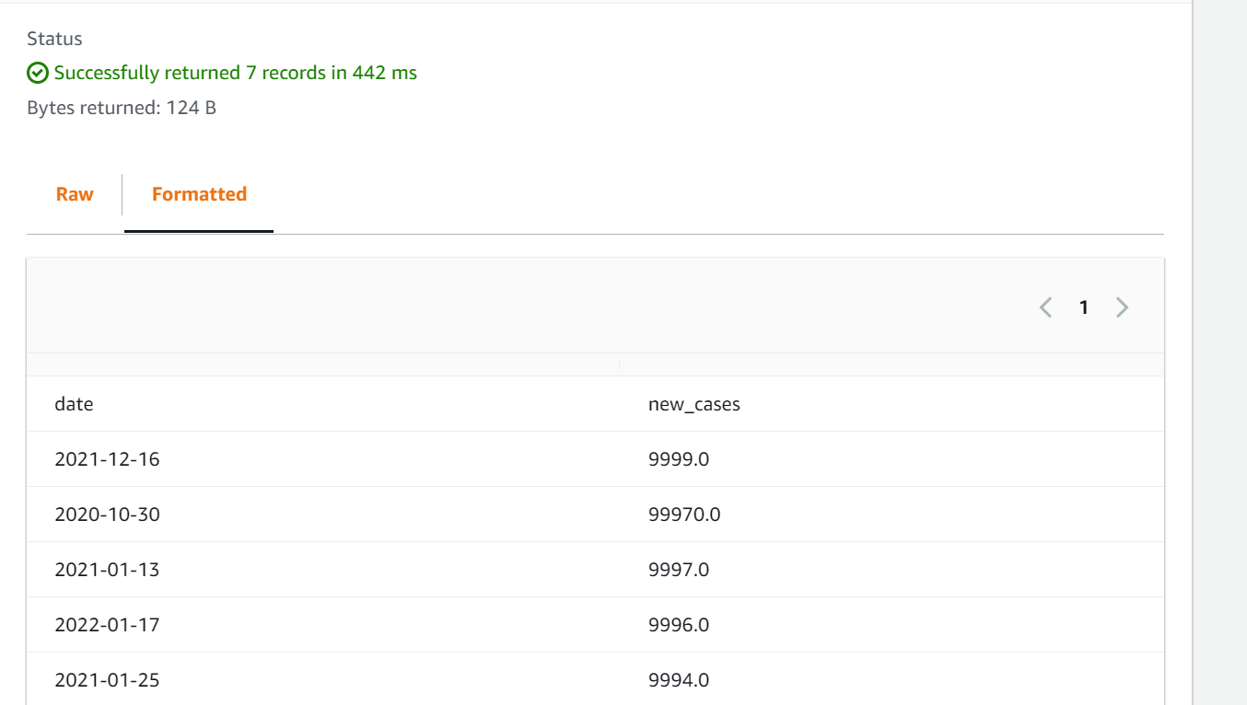

**Job Name: Scala_Practice_5**

**Script:**

import com.amazonaws.services.glue.GlueContext

import com.amazonaws.services.glue.MappingSpec

import com.amazonaws.services.glue.errors.CallSite

import com.amazonaws.services.glue.util.GlueArgParser

import com.amazonaws.services.glue.util.Job

import com.amazonaws.services.glue.util.JsonOptions

import org.apache.spark.SparkContext

import scala.collection.JavaConverters._

import com.amazonaws.services.glue.DynamicFrame

import org.apache.spark.sql.SQLContext

import com.amazonaws.services.glue.errors.CallSite

object SparkSqlQuery {

def execute(glueContext: GlueContext, sqlContext: SQLContext, query: String, mapping: Map[String, DynamicFrame]) : DynamicFrame = {

for ((alias, frame) <- mapping) {

frame.toDF().createOrReplaceTempView(alias)

}

val resultDataFrame = sqlContext.sql(query)

return DynamicFrame(resultDataFrame, glueContext)

}

}

object GlueApp {

def main(sysArgs: Array[String]) {

val spark: SparkContext = new SparkContext()

val glueContext: GlueContext = new GlueContext(spark)

val sql: SQLContext = new SQLContext(spark)

// @params: [JOB_NAME]

val args = GlueArgParser.getResolvedOptions(sysArgs, Seq("JOB_NAME").toArray)

Job.init(args("JOB_NAME"), glueContext, args.asJava)

// Script generated for node S3 bucket

val S3bucket_node1 = glueContext.getSourceWithFormat(formatOptions=JsonOptions("""{"quoteChar": "\"", "withHeader": true, "separator": ","}"""), connectionType="s3", format="csv", options=JsonOptions("""{"paths": ["s3://training-labtarget1/TrainingLab/Amulya/OUTPUT/AWS_UseCase/Covid_Filtered_Data.csv"], "recurse": true}"""), transformationContext="S3bucket_node1").getDynamicFrame()

// Script generated for node SQL

val SqlQuery0: String = """select first(date) from Covid_Case where continent ='Asia'""".stripMargin

val SQL_node1646645020148 = SparkSqlQuery.execute(glueContext = glueContext, sqlContext = sql, query = SqlQuery0, mapping = Map("Covid_Case" -> S3bucket_node1)

)

// Script generated for node Amazon S3

val repartition=SQL_node1646645020148.repartition(1)

val AmazonS3_node1646645050653 = glueContext.getSinkWithFormat(connectionType="s3", options=JsonOptions("""{"path": "s3://training-labtarget1/TrainingLab/Amulya/OUTPUT/Scala/Scala_Practice_5/", "partitionKeys": []}"""), transformationContext="AmazonS3_node1646645050653", format="csv").writeDynamicFrame(repartition)

Job.commit()

}

}

**Output:**

